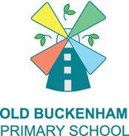 News updates from Old Buckenham Primary School
KEY DIARY DATES
15th April & 16th April: Parent Consultation Meetings (3.15-6pm)- please make an appointment via MCAS
17th April: PTFA Non-Uniform Day Fundraiser: Rainbow Day
24th April: RSHCE Information session for parents with Miss Moll- more information to follow
WB 27th April: MTC Mock Window opens
28th April: Class Photographs
4th May : May Day Bank Holiday – school closed
6th May: PTFA Bag 2 School Fundraiser
15th May: Non Uniform Day: Mental Health Week: ‘Take Action’- wear green- more information to follow
18th - 22nd May :Walk to school Week- more information to follow
21st May: Y6 Fundraiser- Make Day
25th – 29th May: Half Term
PE days are Mondays and Thursdays

YEAR FOUR
NEWSLETTER
April 2026: Summer 1
Welcome back Maple Class.
We hope you have all had a fantastic Easter break and are ready and raring to begin the summer term. We have a very busy half-term planned.

Wel

In

At Home
Homework: The homework sheet will go home with your child at beginning of Summer 1. As always please read with your child and access TT rockstars regularly.
Reading: Reading is a vital part of learning. We ask that you try to hear your child read daily and log this on Boom Reader. If you have problems accessing this app then please let us know, I can reissue log ins.
Maths: fluency with multiplication facts reduces cognitive load, increases efficiency and accuracy. If children find maths tricky, playing frequent games of TTRockstars will help to break down this barrier. The less number facts you confidently know, the harder maths is, so practising times tables is vital. In year 4, children are expected to practice 3x a week or more on TTRS.
Spelling
Each week, spelling homework tasks will be uploaded to Emile. This task will be based on the skills we have been learning in class. Please support your child to log on and practice these skills every week.

Our Lessons: Curriculum Information
Spelling: We continue to use Emile as our spelling scheme. We are learning spelling rules for the suffixs -ary -er and -ar and word families. There will be a task set on Emile for the children to complete as homework every week.
English (Reading): This half term we will be reading Charlotte’s Web We will be using our VIPERS skills and developing our fluency. Thinking about adding expression to our voices and responding to punctuation. Next we will be exploring a selection of poems and performing them.
English (Writing): This half term will be a busy one in our English writing lessons. We will begin with looking at father by Grahame Baker-Smith then explore Journey by Aaron Becker. Continuing to develop our narrative writing skills.
Maths: This half term we will be continuing with our unit on length and perimeter. Then we will be consolidating our understanding of decimals and exploring money. We are also preparing for our MTC and our practice window opens this half term.
Science: In Science this half term, we will be exploring the topic of states of matter. We will focus on how matter can change from one state to another, while developing a range of scientific enquiry skills, including observing and predicting.
RE: In RE we will continue our study of Islam using the key question ‘How does the Qur’an influence Muslims today?’. We will be discussing books that are important to us and discussing why the Qur’an is so important to Muslims.
PSHCE: This half term, our topic will be relationships. We will explore how to build and maintain friendships, as well as learn strategies for resolving friendship challenges. We will also discuss how and why friendships can change over time.
Geography: In Geography this term, we will link our learning in Science to investigate the question, “Why are jungles so wet and deserts so dry?” We will explore climate graphs and examine how climate influences the plants and animals that live in different environments.
Art: In art this half term we will be exploring a unit entitled ‘Festival Feast’ along with the question ‘How might we use art and food to bring us together?’ we will be creating individual sculptures and seeing how they can form part of a larger artwork
Computing: Photo editing – Manipulating digital images, and reflecting on the impact of changes and whether the required purpose is fulfilled. Using a range of editing tools: crop, rotate, duplicate, colour change and combining two or more pictures.

Music: In music this half term, we will be learning to sing and play a series of songs. We will also compose a piece of music using the graphic score – the river.
PE: This half term we will be taking part in athletics and Tennis, learning how to develop running, throwing and jumping techniques. PE days will be Mondays and Thursdays.
French: Our new unit is “On Mange”. We will be learning the names of basic foods, how much it costs, activities at a party and Apply their learning to creating a French shop.

How can you help your child at home?
- Please read regularly with your child asking them questions about what they are reading. These questions can be linked to V.I.P.E.R.S. Then please complete Boom Reader to confirm that they have read with you every day. Please also encourage them to read a variety of fiction, non-fiction and poetry texts.
- 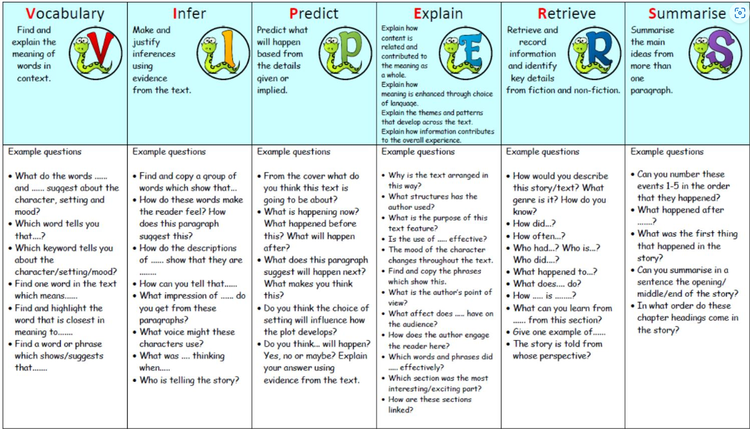
- Encourage your child to learn their spellings from the Year 3 and 4 Statutory Spelling list: SpellingWordList_Y3-4.pdf (oxfordowl.co.uk)
- Please practice any spelling sent home in their homework books.
- In maths, you can support your child at home by practising times tables up to 12 times 12 regularly. This can be incorporated into their day through quick questions, times table songs and games. Turn it into a family competition! Please log in to Times Tables Rockstar at least three times a week.
- Please also encourage your child to access Times Tables Rockstars at home. It is extremely important that the children practice regularly throughout the year to develop their recall. The soundcheck feature gives the children a countdown similar to the Multiplication Table Check.
- If your child shows any interest in their learning outside of school, I would love to see it. Whether this is carrying out their own science experiments, exploring their local area, using their DT skills, or doing some history research!

Please ensure all belongings are labelled, including jumpers, wellies, coats and water bottles.
.

PE: Children should wear their PE kit (white T-shirt, dark shorts/tracksuit trousers, school jumper) to school, with long hair tied up and earrings removed.
PE days will be Mondays and Thursdays
Contact: If you have any queries or concerns, please speak to one of the team at the start or end of the school day. Alternatively, email using Year4@obps.set.education
Many thanks for your support,
Miss McConochie.

